DATE 17/3/2025

EXPERIMENT: 22
IMPLEMENTATION OF IOT BASED SMART GARDENING

Aim: To implement IOT based smart gardening using Cisco packet tracer.
Software/Apparatus required: Packet Tracer/End devices, Hubs, Connectors.
Procedure:
Step 1: Create a new project in Cisco Packet Tracer and drag a generic IoT device from the IoT devices section onto the workspace.
Step 2: Right-click on the IoT device and select Config/Attributes.
Step 3: In the Configuration tab, select the device's IoT server from the drop-down list. You can choose Cisco IoT Cloud or another cloud service of your choice.
Step 4: In the Attributes tab, add the following attributes:
- Temperature
- Humidity
- Soil Moisture
- Light Intensity
Step 5: Create a soil moisture sensor and a light sensor from the Sensors section of the devices panel.
Drag and drop these sensors onto the workspace.
Step 6: Connect the sensors to the IoT device using the wiring tool.
Step 7: Configure the sensors by right-clicking on them and selecting Config/Attributes. Set the sensor type, unit of measurement, and other necessary parameters.
Step 8: Create a water pump and a light bulb from the Actuators section of the devices panel. Drag and drop these actuators onto the workspace.
Step 9: Connect the actuators to the IoT device using the wiring tool.
Step 10: Configure the actuators by right-clicking on them and selecting Config/Attributes. Set the actuator type, command, and other necessary parameters.
Step 11: Save the configuration and run the simulation to test your IoT Smart Garden.
Step 12: Monitor the temperature, humidity, soil moisture, and light intensity readings on the IoT device dashboard.
Step 13: Use the dashboard to control the water pump and light bulb based on the sensor readings.
OUTPUT
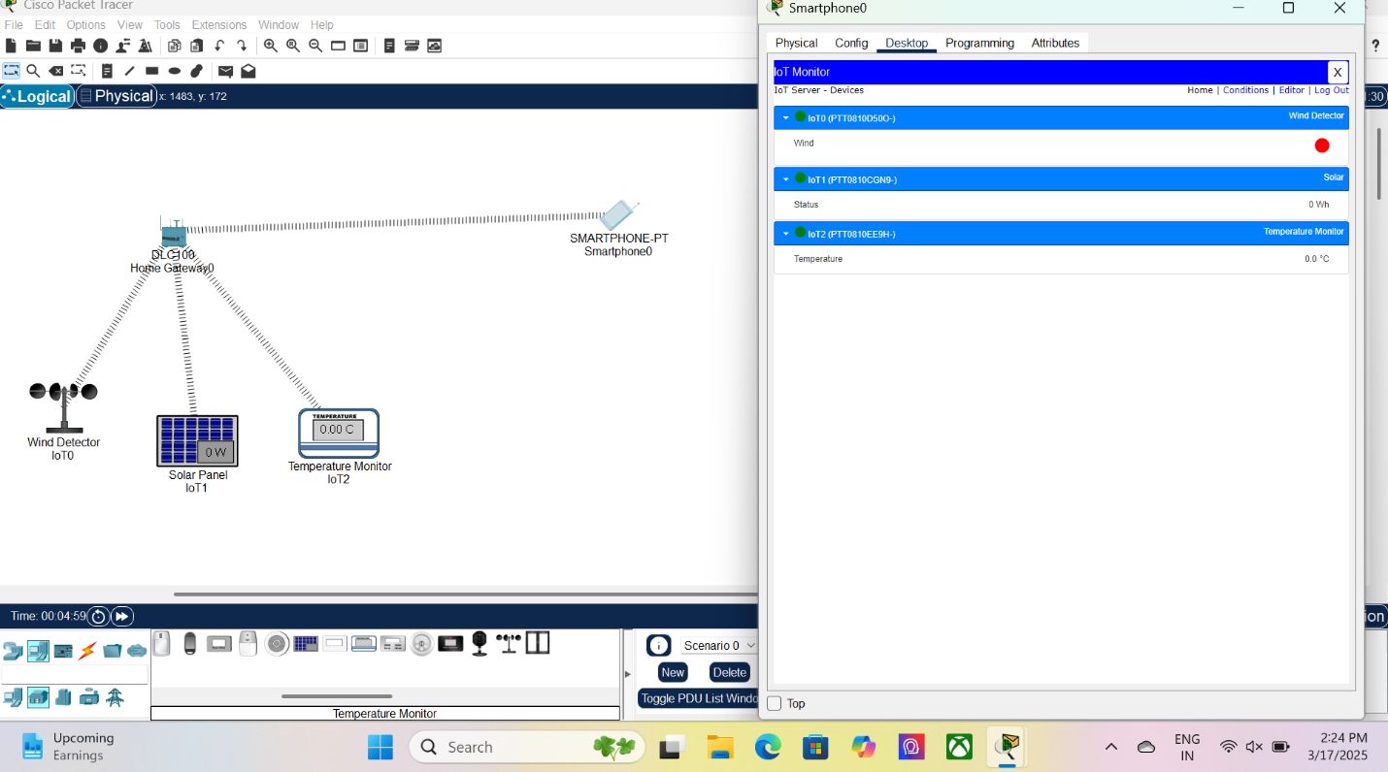

Result: Implementation of smart gardening is carried out using IOT successfully.

